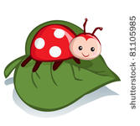 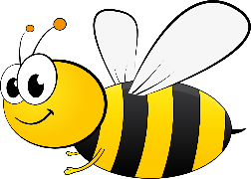

May

By Jan Irvin

May, one of my favorite months, is a month of new beginnings to be shared: the bee’s buzzing, ladybugs hatching, and new baby birds chirping, sharing their joy of spring. The earth prepares itself to produce an abundance of fresh fruits and vegetables to be sold at farmers’ markets or harvested in your own backyard.

However, if you’re like me, not a farmer, the, sneezing sends me to the local pharmacy for allergy medicine or to receive an allergy shot from the doctor or P.A. at the local medical office. But even allergies cannot dampen the joy of spring.

Corning healthcare district invites you to celebrate spring during the corning in the evening event this coming Thursday in the Meuser building. Festivities begin at 5:30.

